FCI-Standard N°86/ 28. 11. 2003 / GB

YORKSHIRE TERRIER

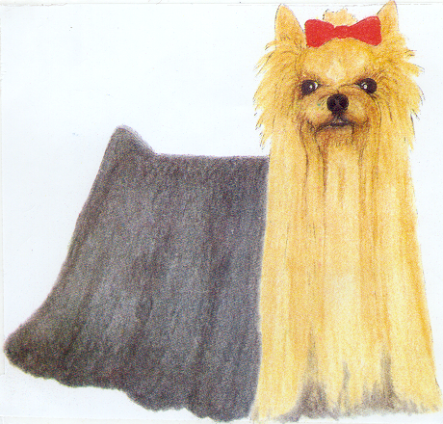

ORIGIN : Great Britain.

DATE OF PUBLICATION OF THE ORIGINAL VALID STANDARD : 29.10.2003.

UTILIZATION : Toy Terrier.

CLASSIFICATION F.C.I. : Group 3 Terriers.
Section 4 Toy Terriers.
Without working trial.

GENERAL APPEARANCE : Long-coated, coat hanging quite straight and evenly down each side, a parting extending from nose to end of tail. Very compact and neat, carriage very upright conveying an important air. General outline conveying impression of vigorous and well proportioned body.

BEHAVIOUR AND TEMPERAMENT : Alert, intelligent toy terrier. Spirited with even disposition.

HEAD

CRANIAL REGION :
Skull : Rather small and flat, not too prominent or round.

FACIAL REGION :
Nose : Black.
Muzzle : Not too long.
Jaw/Teeth : Perfect, regular and complete scissor bite, i. e. upper teeth closely overlapping the lower teeth and set square to the jaws. Teeth well placed with even jaws.
Eyes : Medium, dark, sparkling, with sharp intelligent expression and placed to look directly forward. Not prominent. Edge of eyelids dark.
Ears : Small, V-shaped, carried erect, not too far apart, covered with short hair, colour very deep, rich tan.

NECK : Good reach.

BODY : Compact.
Back : Level.
Loins : Well sustained.
Ribs : Moderate spring o ribs.

TAIL : Customarily docked.
Docked : Medium length with plenty of hair, darker blue in colour than rest of body, especially at end of tail. Carried a little higher than level of back.
Undocked : Plenty of hair, darker blue in colour than rest of body, especially at end of tail. Carried a little higher than level of back. As straight as possible. Length to give a well balanced appearance.

LIMBS

FOREQUARTERS : Legs straight, well covered with hair of rich golden tan a few shades lighter at end than at roots, not extending higher on forelegs than elbows.
Shoulders : Well laid.

HINDQUARTERS : Legs quite straight when viewed from behind, moderate turn of stifle. Well covered with hair of rich golden tan a few shades lighter at ends than at roots, not extending higher on hindlegs than stifle.

FEET : Round ; nails black.

GAIT / MOVEMENT : Free with drive ; straight action front and behind, retaining level topline.

COAT

HAIR : On body moderately long, perfectly straight (not wavy), glossy ; fine silky texture, not woolly. Fall on head long, rich golden tan, deeper in colour at sides of head, about ear roots and on muzzle where it should be very long. Tan on head not to extend on to neck, nor must any sooty or dark hair intermingle with any of tan.

COLOUR : Dark steel blue (not silver blue), extending from occiput to root of tail, never mingled with fawn, bronze or dark hairs. Hair on chest rich, bright tan. All tan hair darker at the roots than in middle, shading to still lighter at tips.

WEIGHT : Weight up to 3,1 kg (7 lbs).

FAULTS : Any departure from the foregoing points should be considered a fault and the seriousness with which the fault should be regarded should be in exact proportion to its degree and its effect upon the health and welfare of the dog.

Any dog clearly showing physical or behavioural abnormalities shall be disqualified.

N.B. : Male animals should have two apparently normal testicles fully descended into the scrotum.

This amended breed standard will become effective from April 2004.

